TOWN OF CALEDONIA
3109 MAIN STREET, CALEDONIA, NY 14423

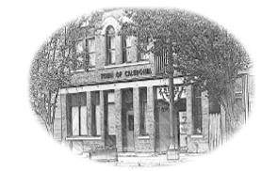

(P) 585.538.4927 • (F) 585.538.6348
www.townofcaledoniany.org
SUPERVISOR |  | TOWN CLERK/TAX COLLECTOR
Daniel L. Pangrazio |  | Seth M. Graham
SUPERVISOR’S CLERK |  | DEPUTY CLERK
Kathryn Raymond |  | Christine Binnert
TOWN BOARD |  | TOWN JUSTICES
Todd Bickford |  | Mark Riggi
Quentin Clark |  | Kyle MacKay
Pamela Rychlicki
Kevin Keenan
 |  | COURT CLERK
HIGHWAY SUPERINTENDENT |  | Margaret Donegan
Ronald Beach III
 |  | ASSESSOR
CODE ENFORCEMENT  Tom Perkins |  | Tami Snyder
HISTORIAN
Eileen Lafave-Bickford
LEGAL NOTICE
MEETING DATE CHANGES
TOWN OF CALEDONIA

Please take notice that the Town of Caledonia Town Board meeting to be held Thursday, May 9, 2024, has been changed to Thursday, May 16, 2024 at 7:00 P. M.

February 9, 2024
By Order of the Town Board
Seth Graham
Town Clerk

